**Assignment 3**

**Team Members**

|  |  |  |  |
| --- | --- | --- | --- |
| **Num** | **Full Name in ARABIC** | SEC | BN |
| 1 | عبد الرحمن محمد حمزه عثمان | 1 | 37 |
| 2 | زياد شريف محمد ابراهيم حسين | 1 | 27 |
| 3 | محمود عبدالحميد على مصطفى | 2 | 22 |

**Table of contents:**

1. Part One 3

1.1 Gram-Schmidt Orthogonalization 3

1.2 Signal Space Representation 4

1.3 Signal Space Representation with adding AWGN 4

1.4 Noise Effect on Signal Space 6

2. Appendix A: Codes for Part One: 7

A.1 Code for Gram-Schmidt Orthogonalization 7

A.2 Code for Signal Space representation 8

A.3 Code for plotting the bases functions 8

A.4 Code for plotting the Signal space Representations 9

A.5 Code for effect of noise on the Signal space Representations 10

**List of Figures**

Figure 1 Φ1 VS time after using the GM_Bases function 3

Figure 2 Φ2 VS time after using the GM_Bases function 3

Figure 3 Signal Space representation of signals s1,s2 4

Figure 4 Signal Space representation of signals s1,s2 with E/σ¬2 =10dB 5

Figure 5 Signal Space representation of signals s1,s2 with E/σ¬2 =0dB 5

Figure 6 Signal Space representation of signals s1,s2 with E/σ¬2 =-5dB 6

# Part One

## 1.1

The function performs **the Gram-Schmidt orthogonalization** process to find two orthogonal basis functions that span the same subspace as the input signals, ensuring that **phi1** and **phi2** are orthogonal to each other and capture the essential characteristics of **s1** and **s2.**

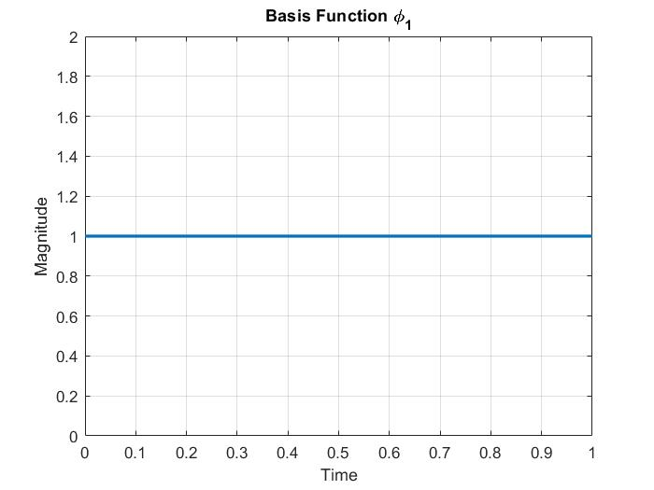Figure Φ1 VS time after using the GM_Bases function

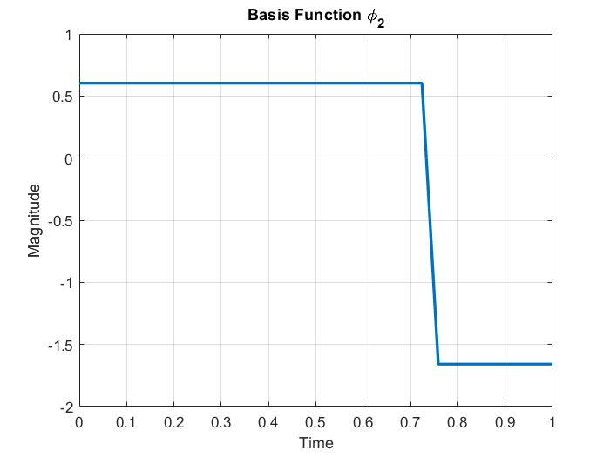Figure Φ2 VS time after using the GM_Bases function

## 1.2 Signal Space Representation

Here we represent the signals using the base functions.

The signal_space function measures **the correlations** between the input signal s and the basis vectors **phi1** and **phi2**. It provides a way to represent the signal s in terms of the contributions from the two basis vectors.

Figure Signal Space representation of signals s1,s2

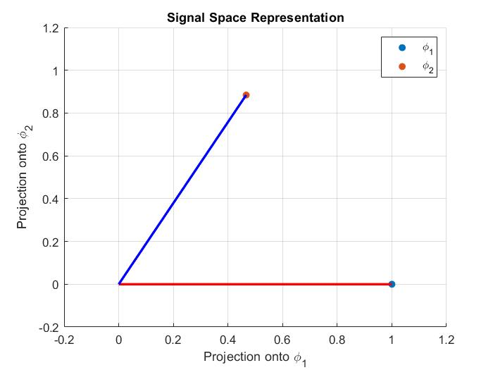

## 1.3 Signal Space Representation with adding AWGN

-the expected real points will be solid and the received will be hollow

**Case 1**: $10 log(E/σ^{2}) = 10 dB$

Figure Signal Space representation of signals s1,s2 with E/σ¬2 =10dB

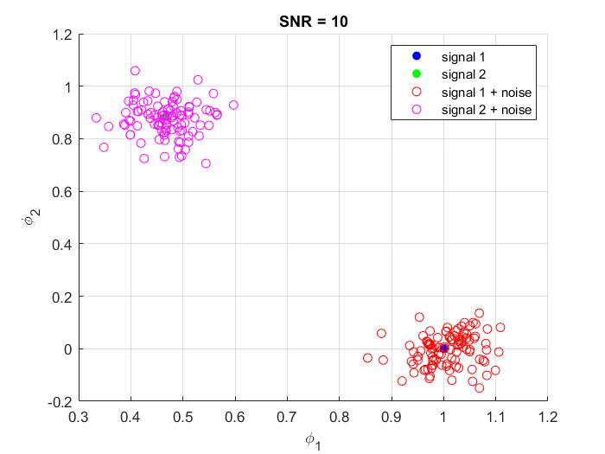

**Case 2**: $10 log(E/σ^{2}) = 0 dB$

Figure Signal Space representation of signals s1,s2 with E/σ¬2 =0dB

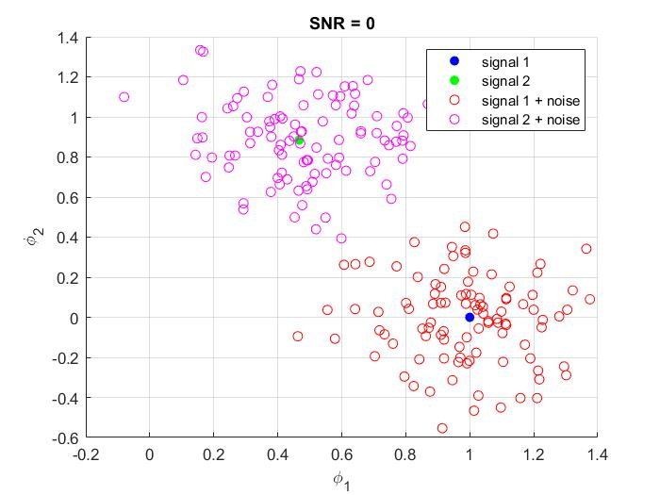

**Case 3**: $10 log(E/σ^{2}) = -5 dB$

Figure Signal Space representation of signals s1,s2 with E/σ¬2 =-5dB

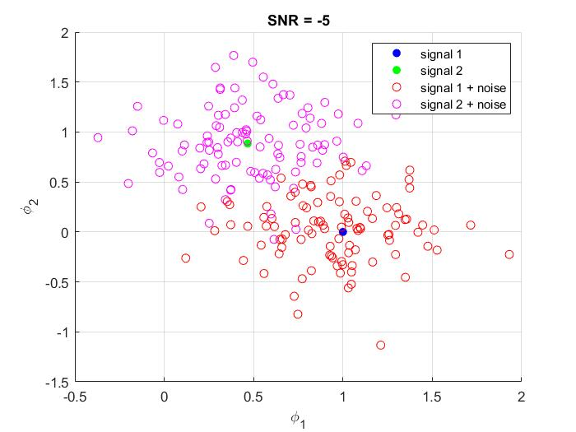

## Noise Effect on Signal Space

# As the noise variance 𝜎^2 increases, the effect of noise on the signal space becomes more noticeable. This results in the signal points being spread out more widely and becoming less concentrated around their ideal positions. The distinction between different signal points becomes less clear, making it harder to distinguish between signals or determine their relative positions in the signal space. In summary, increasing 𝜎^2 amplifies the impact of noise on the signal space representation.

# Appendix A: Codes for Part One:

## A.1 Code for Gram-Schmidt Orthogonalization

function [phi1, phi2] = GM_Bases(s1, s2)

    % Check if the input signals have the same length

    if length(s1) ~= length(s2)

        error('Input signals must have the same length');

    end

    N = length(s1); % Length of the input signals

    % Initialize the basis functions

    phi1 = zeros(1, N);

    phi2 = zeros(1, N);

    % Calculate the first basis function (phi1)

    phi1 = s1 / (norm(s1/(N.^0.5)));

    % Calculate the projection of s2 onto phi1

    proj = dot(s2, phi1) * phi1/N;

    % Calculate the second basis function (phi2)

    phi2 = s2 - proj;

    phi2 = phi2 / norm(phi2/(N.^0.5));

    % Set phi2 to a zero vector if s1 and s2 have one basis function

    if norm(s2 - proj) == 0

        phi2 = zeros(1, N);

    end

end

## A.2 Code for Signal Space representation

function [v1, v2] = signal_space(s, phi1, phi2)

    % Check if the input vectors have the same length

    if length(s) ~= length(phi1) || length(s) ~= length(phi2)

        error('Input vectors must have the same length');

    end

    % Calculate the projections (correlations) of s over phi1 and phi2

    v1 = dot(s, phi1) / length(phi1);

    v2 = dot(s, phi2) / length(phi2);

end

## A.3 Code for plotting the bases functions

%Use your �GM_Bases� function to get the bases functions

%%%%%%%%%%%%%%%%%%%%%%%%%%%%%%%%%%%%%%%%%%

% Obtain the basis functions using GM_Bases function

[phi1, phi2] = GM_Bases(s1, s2);

% Plot the obtained basis functions for s1

figure;

plot(t, phi1, 'LineWidth', 2);

xlabel('Time');

ylabel('Magnitude');

title('Basis Function \phi_1');

grid on;

figure;

plot(t, phi2, 'LineWidth', 2);

xlabel('Time');

ylabel('Magnitude');

title('Basis Function \phi_2');

grid on;

## A.4 Code for plotting the Signal space Representations

% Calculate the signal space representation of s1

[v1_s1, v2_s1] = signal_space(s1, phi1, phi2);

% Calculate the signal space representation of s2

[v1_s2, v2_s2] = signal_space(s2, phi1, phi2);

% Plot the signal space representation for s1 and s2 as scatter plot

figure;

scatter(v1_s1, v2_s1, 'filled');

hold on;

scatter(v1_s2, v2_s2, 'filled');

hold on;

% Plot a line connecting the origin to the specified point

plot([0, v1_s1], [0, v2_s1], 'r','LineWidth', 2);

hold on;

% Plot a line connecting the origin to the specified point

plot([0, v1_s2], [0, v2_s2], 'b','LineWidth', 2);

xlabel('Projection onto \phi_1');

ylabel('Projection onto \phi_2');

xlim([-0.2,1.2]);

ylim([-0.2,1.2]);

title('Signal Space Representation');

legend('\phi_1', '\phi_2');

grid on;

## A.5 Code for effect of noise on the Signal space Representations

% Effect of AWGN on signal space representation

%%%%%%%%%%%%%%%%%%%%%%%%%%%%%%%%%%%%%%%%%%

% Define the SNR levels (in dB)

SNR_levels = [-5, 0, 10];

% Generate samples of r1(t) and r2(t) for each SNR level

for i = 1:length(SNR_levels)

    figure;

    grid on;

    hold on;

    % Plot the signal points

    scatter(v1_s1, v2_s1,'b', 'filled');

    scatter(v1_s2, v2_s2,'g', 'filled');

    for j = 1:100

        % Calculate the noise variance based on the SNR level

        SNR_dB = SNR_levels(i);

        % Generate samples of r1(t) and r2(t) using awgn

        r1 = awgn(s1, SNR_dB, 'measured');

        r2 = awgn(s2, SNR_dB, 'measured');

        % Calculate the signal space representation of r1(t) and r2(t)

        [v1_r1, v2_r1] = signal_space(r1, phi1, phi2);

        [v1_r2, v2_r2] = signal_space(r2, phi1, phi2);

        % Plot the signal points

        scatter(v1_r1, v2_r1,'r');

        scatter(v1_r2, v2_r2,'m');

    end

    xlabel('\phi_1');

    ylabel('\phi_2');

    title(['SNR = ' , num2str(SNR_dB)]);

    % Add legends

    legend('signal 1', 'signal 2','signal 1 + noise','signal 2 + noise');

end